**Visualization #1 - Historical Trends in Formula 1 Racing**

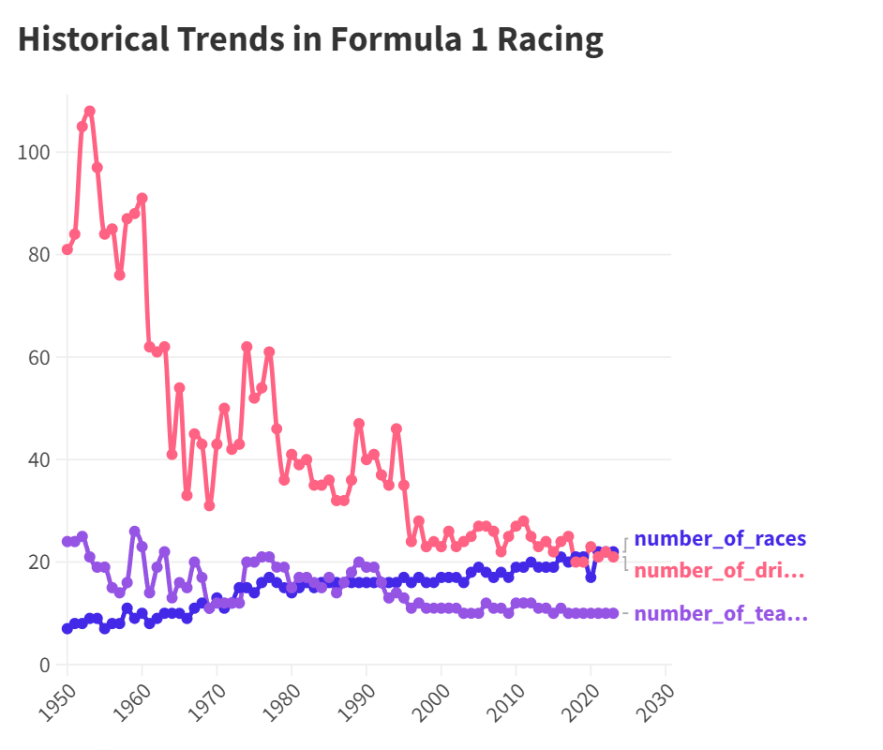

**How It Helps Your Investigation:**

The visualization effectively charts the progression of Formula 1, shedding light on its historical evolution and providing insights into the frequency of races, driver participation, and team involvement across decades.

**Reason for Choosing the Variables:**

The variables—number of races, drivers, and teams—were chosen to holistically represent the scale and growth of F1 over the years, offering a comprehensive view of the sport's expanding popularity and reach.

[**Published link**](https://public.flourish.studio/visualisation/15468255/)

**Visualization #2 - Circuit Distribution**

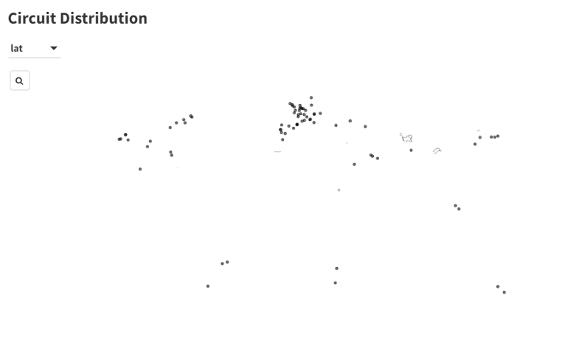

**How It Helps Your Investigation:**

The geospatial distribution of Formula 1 circuits offers a visual understanding of the global footprint of the sport. By mapping out each circuit's location, we can discern the regions that have embraced F1 racing and its historical evolution in terms of new circuits being introduced.

**Reason for Choosing the Variables:**

We chose the latitude and longitude variables to accurately plot each circuit on the global map. The inclusion of 'name', 'location', and 'country' in the metadata for popups ensures that users have immediate context when exploring individual circuits, allowing them to recognize familiar tracks and discover new ones.

[**Published link**](https://public.flourish.studio/visualisation/15468422/)